**DEVOPS ASSIGNMENT**   
  
  
**Initial Pipeline Configuration(Trigger pipeline based on every recent push to github):**  
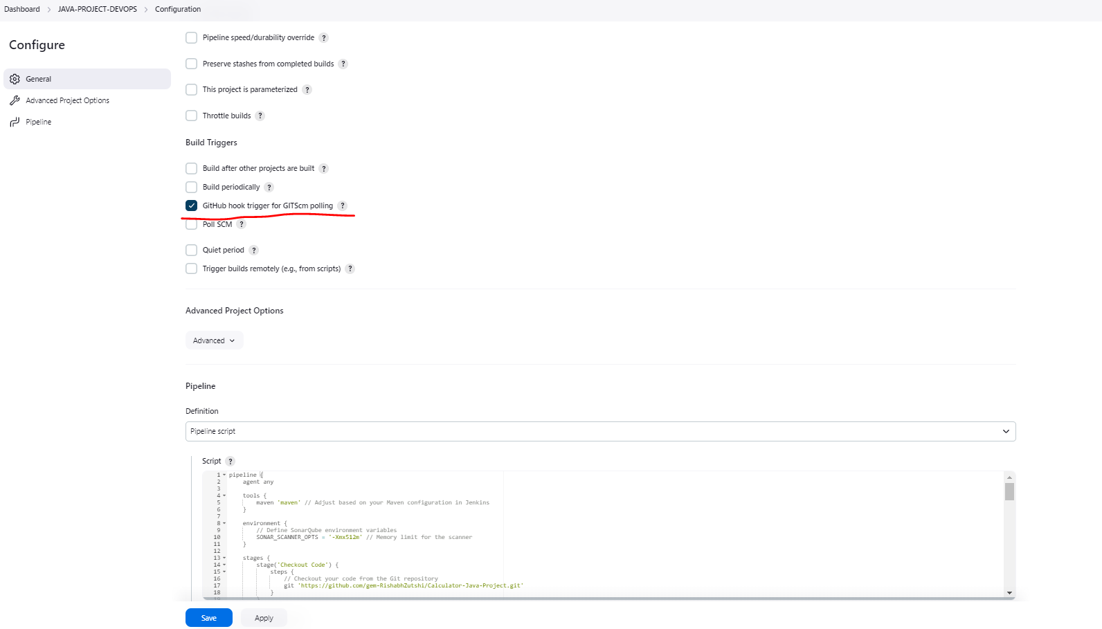  
  
  
**Initial Pipeline Run (with all stages involved):**  
  
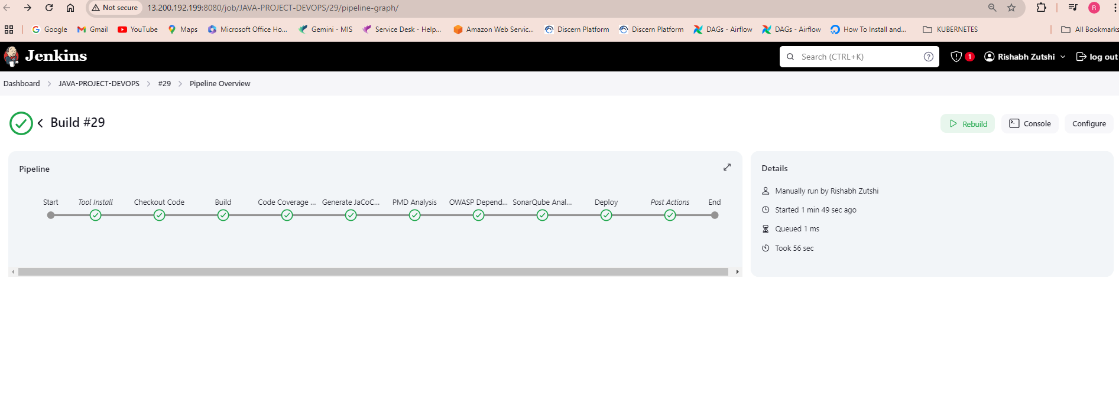  
  
**Pipeline Dashboard Covering all the reports/artifacts generated:**  
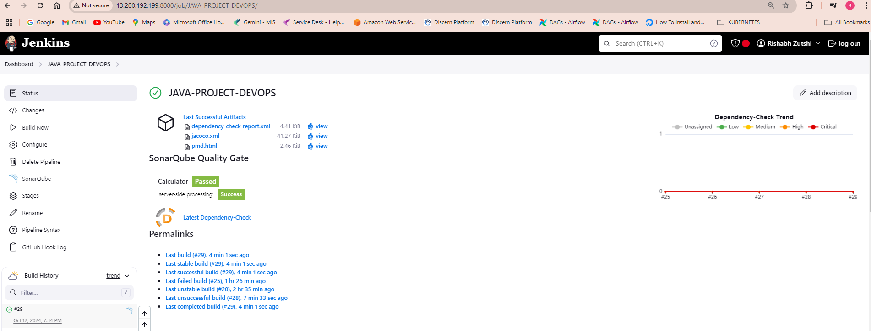  
  
  
  
**Sonarqube Report:**

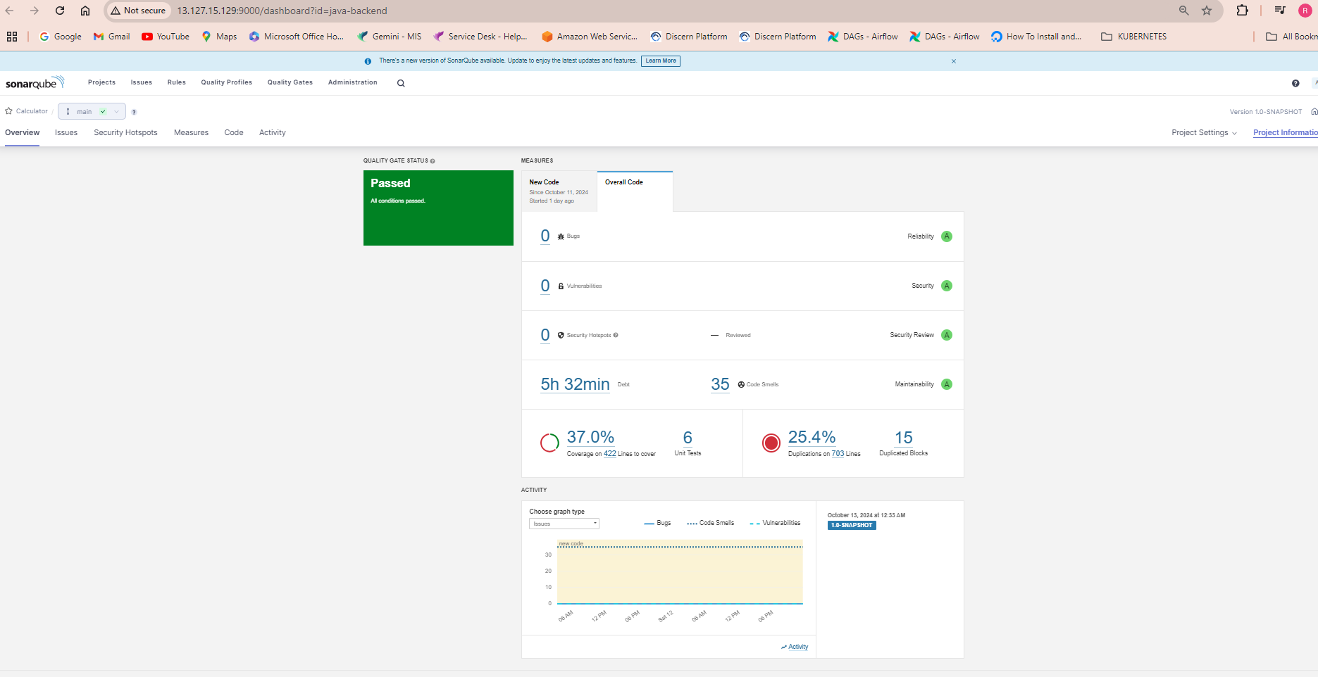

**OWASP Dependency Check Report:**  
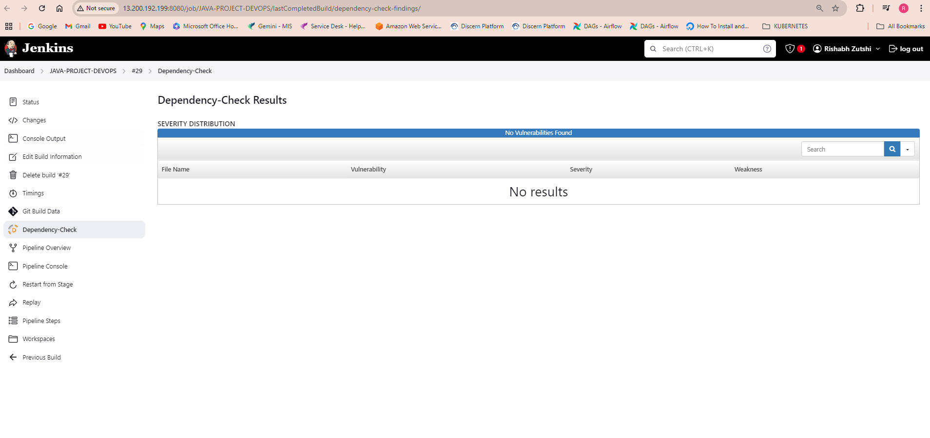  
  
**PMD Report:**  
  
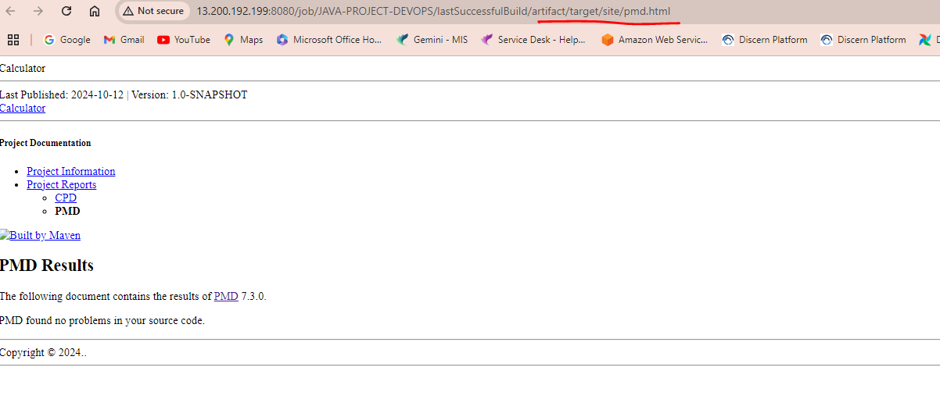

**Jacoco Report for code coverage:**  
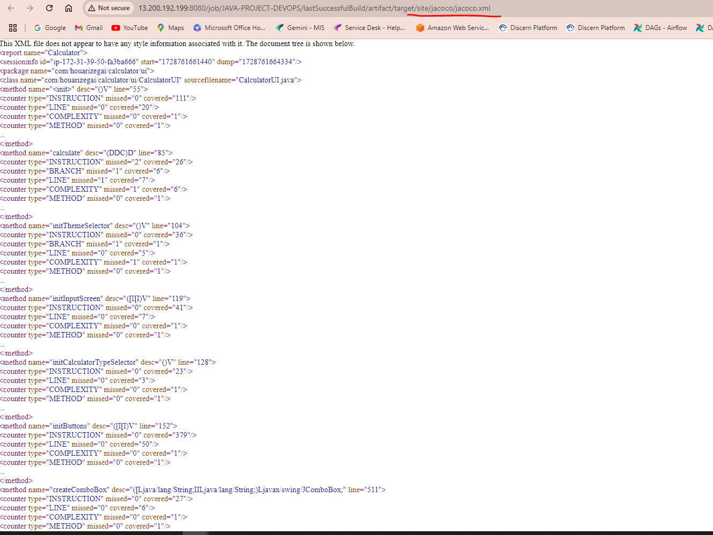  
  
**Configurations:**  
  
Configure/Install Jenkins on E2 server.  
Install the following plugins on Jenkins(MANAGE JENKINS > PLUGINS):  
Git Plugin  
Sonarqube Scanner for Jenkins  
OWASP Dependency Check Plugin  
  
  
Go to MANAGE JENKINS > SYSTEM and:  
Setup sonarqube by adding the Sonarqube server url and SONAR_TOKEN in the SonarQube servers sections.